Identifying and Processing Transfer Requests
Budget Transfers and Interfund Transfers
Overview
A temporary budget transfer is exactly that – temporary. These adjustments will only impact the current fiscal year. A department can complete a Request for Transfer in several different situations. In the past, departments were requesting budget transfers between indexes and funds which did not have true ‘budgets’. When the Budget Transfer Request form was received by Accounting Services, additional entries were being made to ensure that the request was processed properly. These procedures will help to educate people on the proper way to complete the Request for Transfer form. A revision was also made to the Request for Transfer form that will accommodate a transfer between funds. These procedures will assist the preparer in identifying what type of entry is needed and how to document the request on the form.

Forms:
Request for Transfer

Descriptions for funds where transfers may take place

General Fund (Indexes begin with “A”) – The General fund accounts for all assets and resources used for financing the instruction and general administration of the University. The general fund is the only fund containing a ‘true’ BUDGET.

Designated Fund (Indexes begin with “D”) – The Designated fund is used to account for specific activities which are not restricted by donors or supporting agencies. Use of these funds is determined within the University. The following activities are included in the designated fund: unrestricted gift accounts, summer youth programs, faculty start up accounts, IRAD accounts (Institutional Research and Development Funds) and conferences/workshops. The designated fund does not contain a true budget.

Auxiliary Activities Fund (Indexes begin with “H”) – The Auxiliary activities fund accounts for entities within the University that are self-supporting. These types of entities provide services to students, faculty, staff or the public and charge fees to their users. The goal of auxiliary activities is to support the related activities of each enterprise and provide for replacement of facilities used. Included in this fund are the Campus Store, University Images, Memorial Union, Golf Course, Ski Hill, Ice Arena and Residential Services. The Athletic Programs (intercollegiate) are also included in this fund. The auxiliary fund does not contain a true budget, although there are budgets in SOME auxiliary accounts.

Approvals:
The Request for Budget Transfer form requires certain approvals when certain funds are being affected.

Director/Chair approval – required for all transfers
Dean/VP approval – required for transfers between funds and all transfers between SS&E and S&W
Sponsored Programs/Grad School approval – required if research, research incentive (IRAD) or Graduate Stipend funds are involved
Budget Office – required for all transfers

Glossary:
Reduce – to take out of index/account
Increase – to put funds into index/account
Fringe Benefits – Compensation made to an employee beyond the regular benefit of being paid for their work. At Michigan Tech, fringe benefits are charged to every index using an approved pooled rate.
Account Pool – The 4 or 5 digit letter/number combination that categorizes expenditures into accounts/categories (such as payroll, travel, and supplies)
Account Code – The 4 or 5 digit letter/number combination that breaks down the account pool into specific descriptions.
Rule Class Code – ‘packets of posting instructions’, a code which tells Banner how a transaction is to be processed
BD04 – Banner Rule Class for Temporary Budget Adjustments
FT01 – Banner Rule Class for Interfund Transfers (use when an index does not have a budget – a transfer between different funds)
Account Code T190 - Non-mandatory Transfers (out)
Account Code T140 - Non-mandatory Transfers (in)
Reallocation – moving an expense (including payroll) from one index to another or from one account code to another to correct clerical or bookkeeping errors
S&W - Salary and Wages
SS&E - Supplies, Services, and Equipment

Notes:
The following types of transactions are not considered budget transfer or funds transfer entries and should not be processed using the Request for Transfer form. The forms to be used are indicated below:

- Reallocation of Expenditures: used to move expended amounts (funds already spent) – This form is also used to correct entries which were previously incorrect. A rule to follow – If the funds are already spent and you just have to correct a mistake or change the index or the account code that is charged, then a reallocation should be completed.

Transfers affecting the following accounts/funds should happen infrequently. Should a transfer be necessary, consult Accounting Services (7-2242) and/or Sponsored Programs (7-2244):

- Transfers to and from Lab Accounts* (contact Accounting Services)
- Transfers involving Expendable Restricted funds, which are used to account for activities which are restricted for specific purposes by external agencies and donors. (contact Sponsored Programs Accounting)
- Transfers involving Agency Funds, which are used to account for assets received by the University to be held or disbursed only on the instruction or on behalf of the persons or organizations who provided the funds. (Indexes beginning with “S7”).

*General fund lab indexes do not have budgets. Lab funds are intended to be spent directly out of the lab indexes and shouldn’t be transferred out. In the rare event that funds must be transferred into a lab index from another general fund index, an intrafund transfer code, T200, is used. An example:

JE15: Charge A11111-T200 and credit the lab index A12222-T200.

Summary - conclusion

A ‘true’ budget transfer is one involving non-lab general fund indexes. Since there are no budgets in lab accounts, these procedures pertain to any ‘non-lab general fund indexes’. (Lab accounts are discussed at the end of these procedures). This would include a transfer between a general fund and another general fund or transferring between different account pools in the same general fund index. These types of transfers can only be made using the Rule Class BD04.

In summary: When funds are transferred into or out of the General Fund from other funds, there are two required transactions. The actual funds are transferred (FT01) and a budget transfer (BD04) is done in the General Fund index to properly align the budget pools. So if you want to request a transfer from General Fund to another fund (Auxiliary, Designated or Expendable Restricted) the following entries are made (defined by Rule Class):

- BD04: Decrease the budget in A11111-E200 (or appropriate budget pool) and increase the budget in A11111-T190 – this aligns the general fund budget so the transfer code is budgeted.
- FT01: Charge A11111-T190 and credit D99999-T140, this moves the actual funds.

When funds are being transferred into the General fund FROM another fund:

- FT01: Charge D99999-T190 and credit A11111-T140 – this moves the actual funds.
- BD04: Decrease the budget in A11111-T140 and increase the budget in A11111-E200 (or the appropriate budget pool where the funds will be spent).

NOTE that account codes T140 and T190 must be cleared after each entry. The applicable examples will contain a clearing entry to be specified by each department. If the department neglects to indicate which account code to place the budgeted funds, Accounting Service will automatically clear these accounts by adjusting account code E200 (Services).

The following pages will show numerous detailed examples of how and when to complete the Request for Transfer form and the use of the Funds Transfer entries. Remember to obtain proper approval for each transfer (as described on the Transfer Form and on page 1 of this document).

EXAMPLE #1: General Fund (SS&E) to General Fund (SS&E)

Example of a General Fund to General Fund Budget transfer between two general funds: Sample One Department (A11111) wants to provide Sample Two Department (A11222) with $5000 from their Supplies account (E200) (1) to help fund some travel needs (Account E700) of Sample Two Department (2).

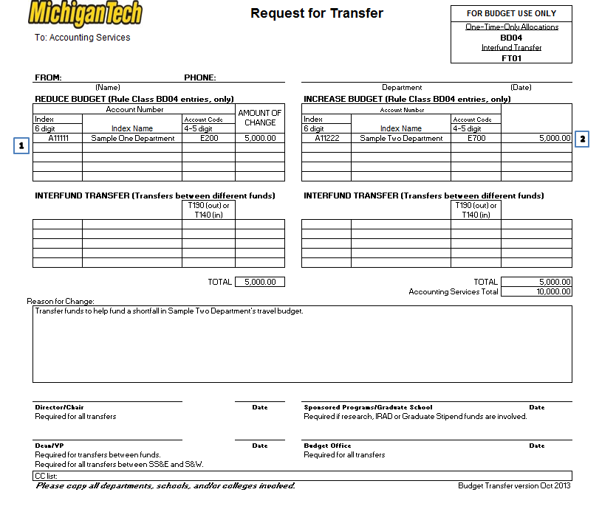

EXAMPLE #2 - General Fund (S&W) to General Fund (S&W)
The next example is a transfer of general fund to general fund that involves the movement of salary. Whenever you move faculty and/or staff salary, you must also move the fringes associated with those salaries. The account codes for salaries begin with P while the fringe benefit account code is B001. The fringe rate generally changes from year to year and the current year rate can be found on the Research Facts and Figures webpage. Calculate the fringe amount based on the salary being transferred (a fringe rate of 38% is used in this example). In this case, $10,000 in faculty salary is being moved from one index (1) to another (2) so $3800 in fringes ($10000 x 38%) has to be moved, as well, using account code B001.

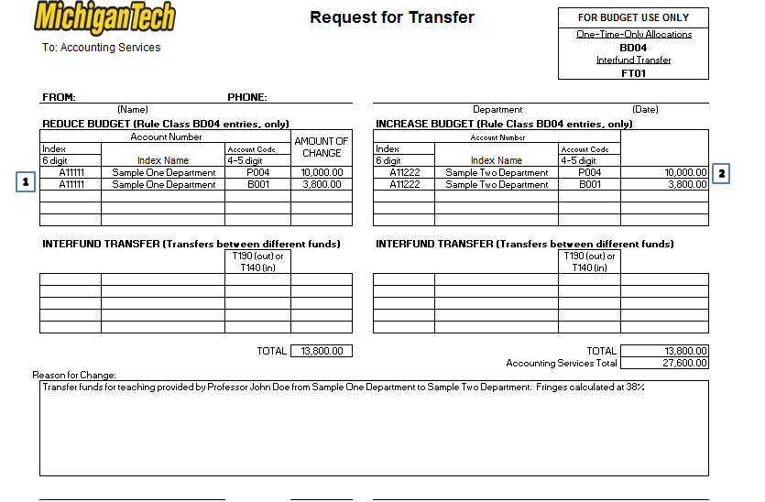

EXAMPLE #3: General Fund (SS&E) to General Fund (S&W)
The next example is a transfer of general fund to the same general fund that involves movement of supplies to salary. The associated fringes must also be considered.

Sample One Department is in need of an additional $10,000 in salary to cover an unexpected shortfall. They have enough in supplies (E200) to cover this but they also must consider the fringes associated with the $10K in salary. First determine how much in fringes they must cover - the fringe rate is 38%, so $3,800 ($10,000 x 0.38) is needed to cover the fringes (2). This amount is to be added to $10,000 which will result in $13,800 needed from the supplies account (1).

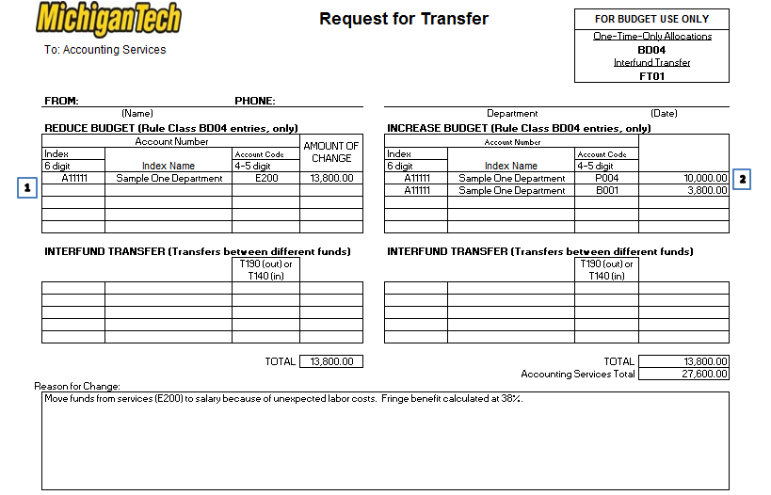

EXAMPLE #4: General Fund (SS&E) to Designated Fund

Sample Dept One wants to transfer $1000 to Designated Fund One for Parade of Nations support. Using a BD04 (temporary budget transfer request) rule class, move $1000.00 from the appropriate account pool – in this case, they want to move it out of E600 (1) – to account code T190 (mandatory transfer out) in the same index (2). To clear the T190 code, use rule class FT01 to then decrease T190 (index A11111) (3) and increase D99999, account code T140 (mandatory transfers in) (4).

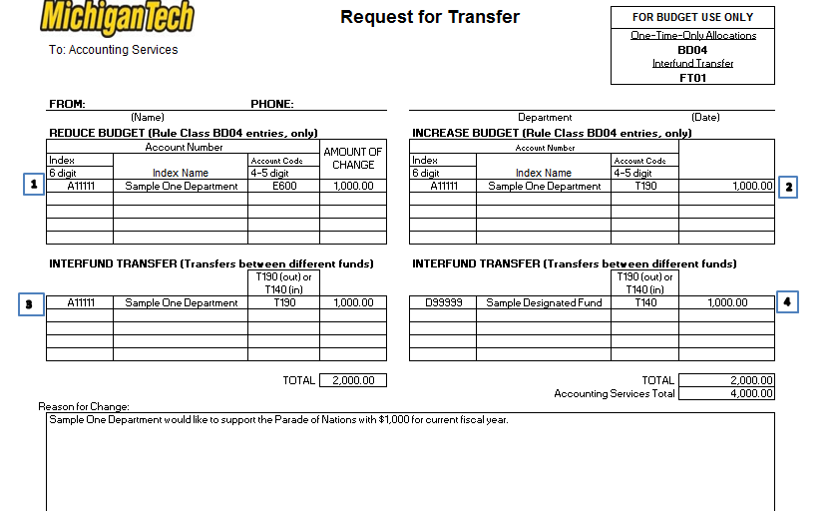
.

EXAMPLE #5 – Designated Fund to General Fund (to S&W):
Start by creating a funds transfer entry (FT01) to move the money from D99999 with account code T190 (1), to A11111, with account code T140 (2). Next, create a budget transfer entry (BD04) to budget the transfer account code of T140 in index A11111 (3) and increase the salary account codes, as necessary. Don’t forget to include enough to cover the fringes. In the example, we needed $5000 in salary money but we also need to move 38% in fringes, so 5000 * 0.38 = $1900. This much needs to come from D99999. The final entry is made to increase P006 (professional salary) by $5000 and B001 (fringes) by $1900 (4).

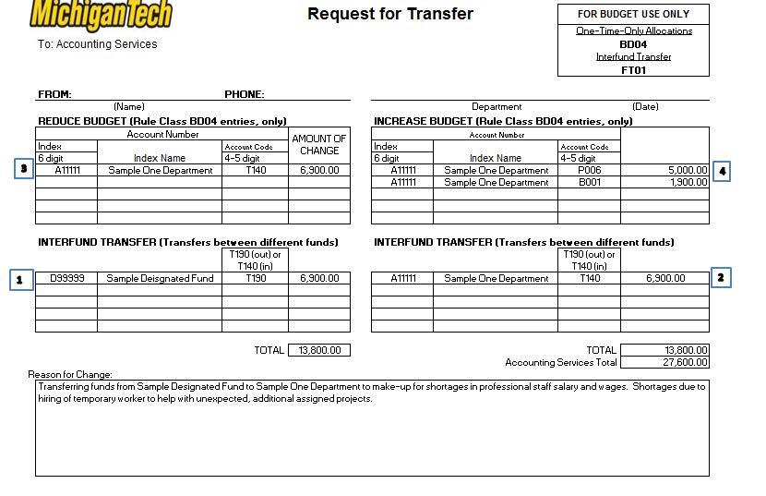

EXAMPLE #6: Auxiliary Fund to General Fund
Example of transfers
One example of a transfer involving an auxiliary account is the movement of funds from the Tennis Center Auxiliary and the Tennis Experience Tech Fee Equity to the Tennis Center (General Fund Account). The first step is taking funds OUT of the auxiliary accounts (H41111 and H43333) using account code T190 (1) and moving them INTO the general fund Tennis Center account (A11115) using the T140 account code (2). Because funds should not remain in the T140 account, the department should move them to an appropriate account code within their general fund index (note that the default account code that Accounting will use for funds the department does not move from T140 will be E200 (Services)). In this example, the department wanted to use the funds for supplies (E600) (3) and (4).

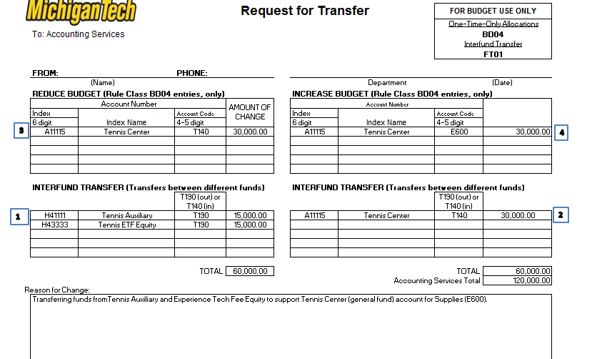

EXAMPLE #7 – General Fund to General Fund affecting Release time
Release Time – When an outside sponsor agrees to pay for an academic year salary, a department then gains access to the General Fund salary and associated fringes for that salary. This is only possible when the release time is funded from an outside sponsor. In doing this transfer, the associated fringes are transferred at the approved fringe benefit rate, regardless of the rate that is being paid by the sponsor. For this type of transfer to be allowed, a copy of the payroll report which reflects the generated salary time in the associated research index needs to be attached to the budget transfer request form. There may be times when you need to capture and transfer the fringes associated with release time from the departmental general fund account to another fund.

Example of a budget transfer involving release time:
In this example, let’s assume that a portion of Professor Bee and C’s salary was paid for by a NSF grant during the fiscal year. This would ‘free up’ the portion of their general fund (‘Academic Department’ in this example) salary. In this example, the department would like to move the funds to their IRAD (Institutional Research and Development Funds). First of all, the salary and fringe amounts (calculated at 38% for faculty salaries) are moved out of the P004 and B001 accounts into the Transfer code, T190 (use BD04) (1) and (2). The FT01 (Funds Transfer) entry should then reflect the movement from account code T190 to T140 (3) and (4).

